**Angeles  City Science High School**

**Conchem 9**

**Name:** Paul Gerald D. Pare **Section:** 9 - Adenine

#### Activity 4: Food Codes

Objective: Identify the food additives found on the different products

Direction: Use the International Numbering System in categorizing the following codes. Complete the table below

|  |  |  |
| --- | --- | --- |
| **Code** | | **Type of Food Additives** |
| 1. | E106 | Colors |
| 2. | E239 | Preservatives |
| 3. | E909 | Surface coating agents, gases, sweeteners |
| 4. | E1222 | Additional chemicals |
| 5. | E409 | Thickeners, stabilizers, emulsifiers |
| 6. | E267 | Preservatives |
| 7. | E311 | Antioxidants, acidity regulators |
| 8. | E345 | Antioxidants, acidity regulators |
| 9. | E542 | Acidity regulators, anti-caking agents |
| 10. | E660 | Flavor Enhancers |

Guide Questions

1. How are ingredients listed on a product label according to International Numbering System (INS) for food additives?

The E system, developer by the European Union (formally the European Economic Community), provides a listing of several commonly used additives, pinkish color of nitrate will be overpowered by the natural color of meat

1. What is the similarity between codes?

The letter E before the numerical description is the similarity between codes.

1. What is the difference between codes?

The difference between codes are numerical description.

## Activity No. 5: Space Puzzle

Objectives

* 1. Describe the chemical composition of sugar.
  2. Construct sentences about the chemical composition of sugar.

Direction: Analyze the following sentences written below. These sentences have INCORRECT SPACES. Rewrite these sentences with CORRECT SPACES on the lines provides below.

1. Sug arisa gen erictermfo racategoryofcarb ohydrateco mpoundsk nown ass ucrose (**C12H22O11**).
2. Agrou pofrelatedco mpo unds arecorns ugar(gluc oseorde xtrose),frui tsugar(fructose),mi lksugar(lac tose)andm altsugar(malt ose).

gars,ormo nosacch araides—glu coseandf ructose.

**3)** Sucroseisadisaccharide;th atis,itismade upoftw osimp lesu

1. Itisco lourle ss,wat er-solu bleco mpoun dspre senti nthesap ofsee dplan tsand them ilkofm amma lsandm akin gupthesi mplestgro upofcar bohydrates.
2. Them ostcom monsu garissucr ose,acrystalli netablet opandind ustrial sweet enerusedin foodsan dbevera ges.
3. Sugar is a generic term for a category of carbohydrate compounds known as sucrose(C12H22O11)
4. A group of related compounds are corn sugar (glucose or dextrose), fruit sugar (fructose), milk sugar(lactose) and malt sugar (maltose).
5. Sucrose is a disaccharide; that is, it is made up of two simple sugars, or monosaccharides - glucose and fructose.
6. It is colourless, water-soluble compounds present in the sap of seed plants and the milk of mammals and making up the simplest group of carbohydrates.
7. The most common sugar is sucrose, a crystalline tabletop and industrial sweetener used in foods and beverages.

Guide Questions

1. What is the similarity between sucrose, maltose and carbohydrates?

These are all organic compounds.

1. What are the elements found in sucrose that is also present on maltose?

Carbon, Hydrogen, and oxygen.

#### Activity 6: Natural Sugar VS Artificial Sweetener

Objective/s

* 1. Differentiate natural sugar to artificial sweetener
  2. Construct the diagram to show the similarities and differences of natural sugar and artificial sweetener

Direction: Show the similarities and differences of natural sugar and artificial sweetener by completing the Venn diagram below.

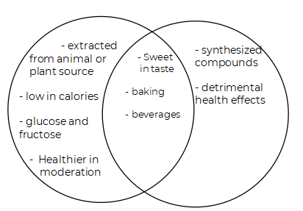

Guide Questions:

1. Which sugar contains more nutrients?

Natural Sugar

1. What sugar is found in local delicacy “inuyat”?

Molasses

#### Activity 7: Honey on Pie

Objective/s

* 1. Describe the chemical composition on natural sugar - Honey
  2. Construct the pie chart to summarize the chemical composition

Direction:

1. Read carefully the text below.
2. Show the percentage of the chemical composition of honey using a pie chart
3. Color and Labelyour pie chart.

*Honey contains trace amounts of several vitamins and minerals. As with all nutritive sweeteners, honey is mostly sugaring and is not a significant source of vitamins or minerals. Honey also contains tiny amounts of several compounds thought to function as antioxidants, including chrysin, pinobanksin, vitamin C, catalase, and pinocembrin. The specific composition of any batch of honey depends on the flowers available to the bees that produced the honey.*

*A typical honey analysis goes as follows: Fructose: 38.2%, Glucose: 31.0%, Sucrose: 1.5%, Maltose: 7.2%, Water: 17.1%, Higher sugars: 1.5%, Ash: 0.2%, Other/undetermined: 3.2%. Honey has a density of about 1.36 kg/L (36% denser than water) (68). The pH of honey is commonly between 3.2 and 4.5. This relatively acidic pH level prevents the growth of many bacteria.*

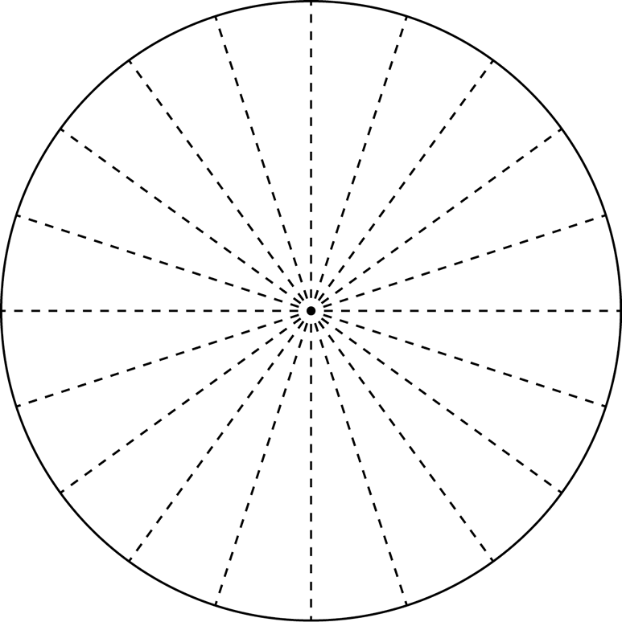Construct your pie chart here. Hint: each slice of pie is equal to 5%.

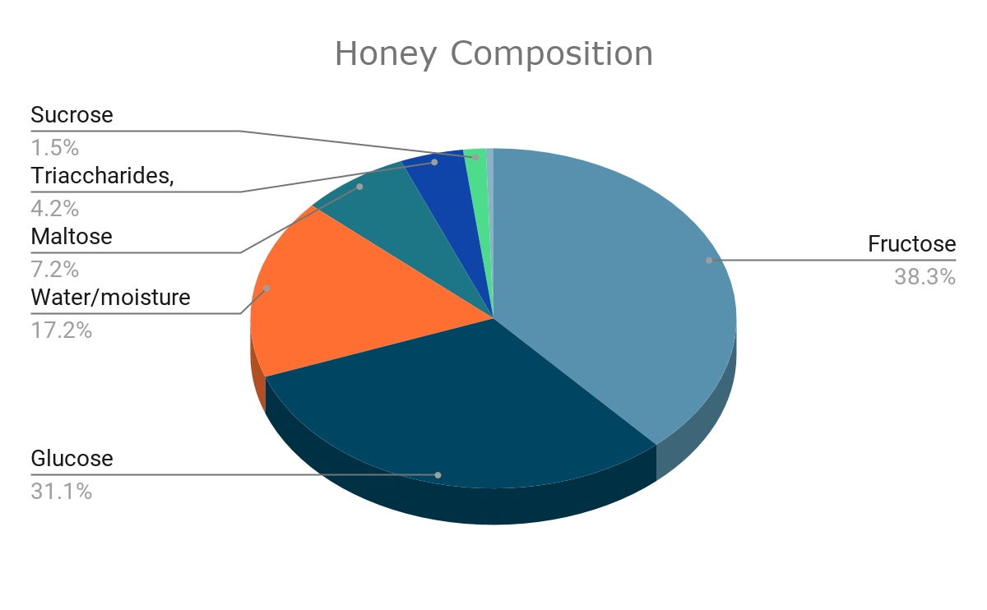

Guide Question:

1. What are the compounds present on honey?

Fructose: 38.2%, Glucose: 31.0%, Sucrose: 1.5%, Maltose: 7.2%, Water: 17.1%, Higher sugars: 1.5%, Ash: 0.2%, Other/undetermined: 3.2%

1. Which compound has the highest percentage?

Fructose

1. What compound has the lowest percentage?

Ash

1. Do you think honey is healthier to artificial sweetener? Why or why not?

Yes, because it is a natural sugar.